Pre-bid Site Meeting Directions for the
West Oakland Bay, West Lobe Restoration
When: November 20, 2018 10:00 AM (please arrive around 9:30)
Where: Sierra Pacific Industries, Shelton Office
421 S. Front Street
Shelton, WA 98584
Safety Equipment Required: Hard Hat, High-vis vest, safety glasses, PPE
Contact: Brian Combs, 360-951-4661, brianc@spsseg.org
This Pre-bid meeting will start at the Sierra Pacific Office and we will then walk to the job site. All personnel must check in with the Project Manager, Brian Combs, in the parking lot in front of the office. This property is otherwise not open to the public and any persons not checking in with the Project Manager will not be authorized on the site. Please arrive by 9:30 or shortly after so we will have time to get to the job site by 10:00.
Safety Equipment as listed above is required while on the site.
Parking is limited so please utilize street parking or visitor parking as available.
Directions:
SPI office is located at 421 Front Street, Shelton, WA 98584.
From Olympia, WA
Follow US-101 N to WA-3 N in Kamilche.
Take the WA-3 N exit from US-101 N.
Follow WA-3 N to S Front St in Shelton.

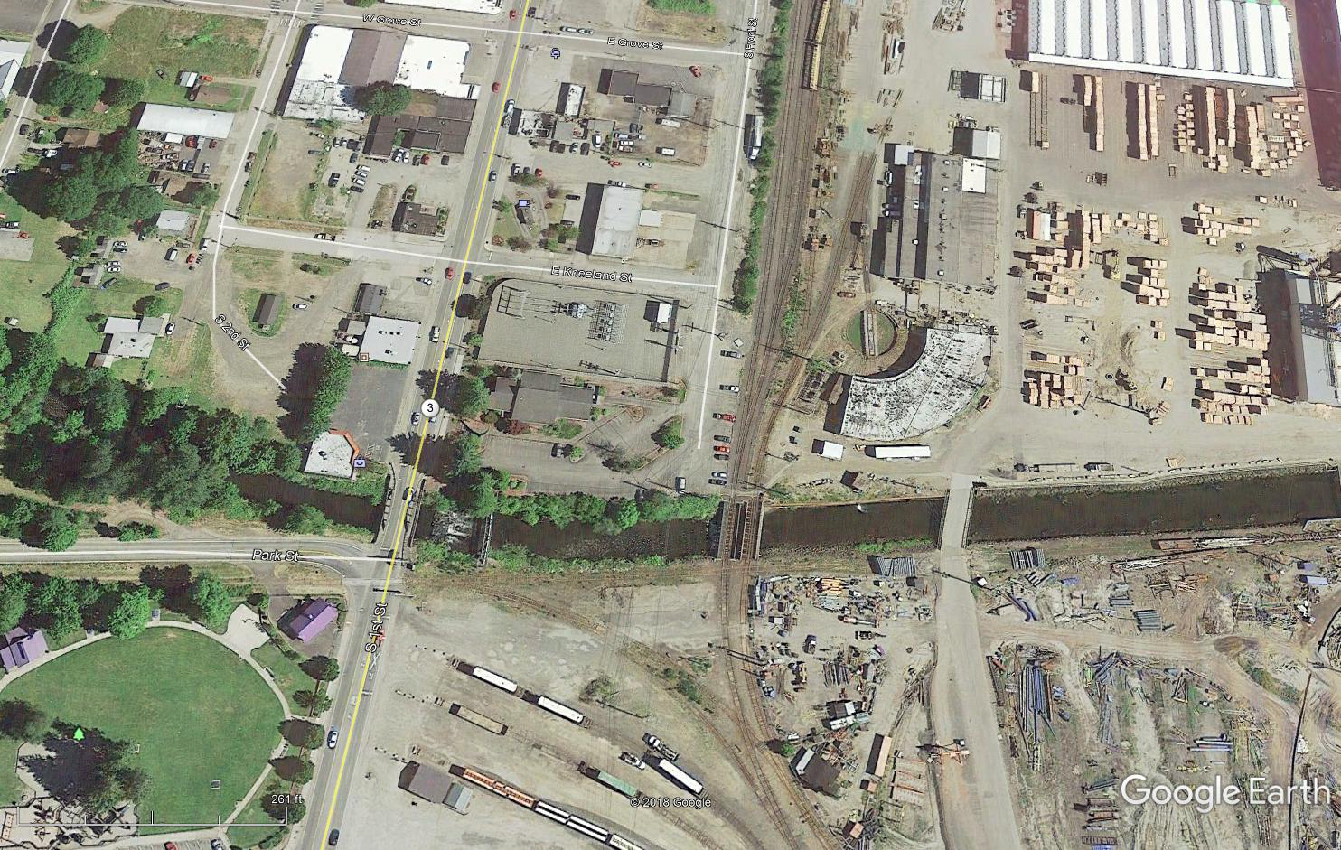
Meet in SPI Parking Lot
421 S Front St.

